**Master – Master Replication**

Edit the /etc/mysql/my.cnf file on each of the Nodes. Add or modify the following

**Master Server 1 : 192.168.227.131**

**Master Server 2 : 192.168.227.132**

**Slave Server 1 : 192.168.227.133**

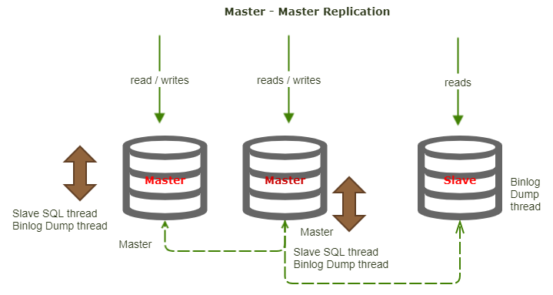

**Server 1:**

/etc/mysql/my.cnf

[mysqld] — Under this parameter only you have to copy the below parameters

server_id = 1

log_bin = /var/log/mysql/mysql-bin.log

log_bin_index = /var/log/mysql/mysql-bin.log.index

relay_log = /var/log/mysql/mysql-relay-bin

relay_log_index = /var/log/mysql/mysql-relay-bin.index

expire_logs_days = 10

max_binlog_size = 50M

log_slave_updates = 1

|  |
| --- |
| bind-address = 0.0.0.0 |

|  |  |
| --- | --- |
|  |  |

**Server 2:**

/etc/mysql/my.cnf

[mysqld] — Under this parameter only you have to copy the below parameters

server_id = 2

log_bin = /var/log/mysql/mysql-bin.log

log_bin_index = /var/log/mysql/mysql-bin.log.index

relay_log = /var/log/mysql/mysql-relay-bin

relay_log_index = /var/log/mysql/mysql-relay-bin.index

expire_logs_days = 10

max_binlog_size = 50M

log_slave_updates = 1

|  |  |
| --- | --- |
|  | bind-address = 0.0.0.0 |

Once completed, restart the MySQL Server:

sudo systemctl restart mysql

**Create Replication Use**

Master Server 1

GRANT REPLICATION SLAVE ON *.* TO 'repluser'@'**192.168.227.132**' IDENTIFIED BY 'repl123'; [ Server 2 ipaddress ]

Master Server 2

GRANT REPLICATION SLAVE ON *.* TO 'repluser'@'**192.168.227.131**' IDENTIFIED BY 'repl123'; [ Server 1 ipaddress ]

**Configure Database Replication**

While logged into MySQL on Server 1, query the master status:

SHOW MASTER STATUS;

Note the file and position values that are displayed:

mysql> SHOW MASTER STATUS;

+------------------+----------+--------------+------------------+

| File | Position | Binlog_Do_DB | Binlog_Ignore_DB |

+------------------+----------+--------------+------------------+

| mysql-bin.000001 | 277 | | |

+------------------+----------+--------------+------------------+

1 row in set (0.00 sec)

On Server 1

CHANGE MASTER TO master_host='192.168.227.132', master_port=3306, master_user='repluser', master_password='repl123', master_log_file='mysql-bin.000005', master_log_pos=154;

START SLAVE;

[ Server 2 ipaddress ]

On Server 2, query the master status. Again note the file and position values.

SHOW MASTER STATUS;

On Server 2

CHANGE MASTER TO master_host='192.168.227.133', master_port=3306, master_user='repluser', master_password='repl123', master_log_file='mysql-bin.000001', master_log_pos=756;

START SLAVE;

[ Server 1 ipaddress ]

Test by creating a database and inserting a row:

**Master Server 1:**

create database test;

use test;

create table test.student(id int primary key,name char(30));

**Master Server 2:**

show tables in test;

When queried, you should see the tables from Server 1 replicated on Server 2. Congratulations, you now have a MySQL Master-Master cluster!

ERROR:-

ERROR 1872 (HY000): Slave failed to initialize relay log info structure from the repository

reset slave;

**Server 3 : Slave Configuration**

/etc/mysql/my.cnf

[mysqld]

server_id = 3

|  |  |
| --- | --- |
|  | bind-address = 0.0.0.0 |

$sudo systemctl restart mysql

**In Server 2**

GRANT REPLICATION SLAVE ON *.* TO 'repluser'@'**192.168.227.133**' IDENTIFIED BY 'repl123'; [ Server 3 ipaddress ]

In Server 3 [ Slave ]

CHANGE MASTER TO master_host='192.168.227.132', master_port=3306, master_user='repluser', master_password='repl123', master_log_file='mysql-bin.000006', master_log_pos=455;

[ Server 2 ipaddress ]

Start slave;